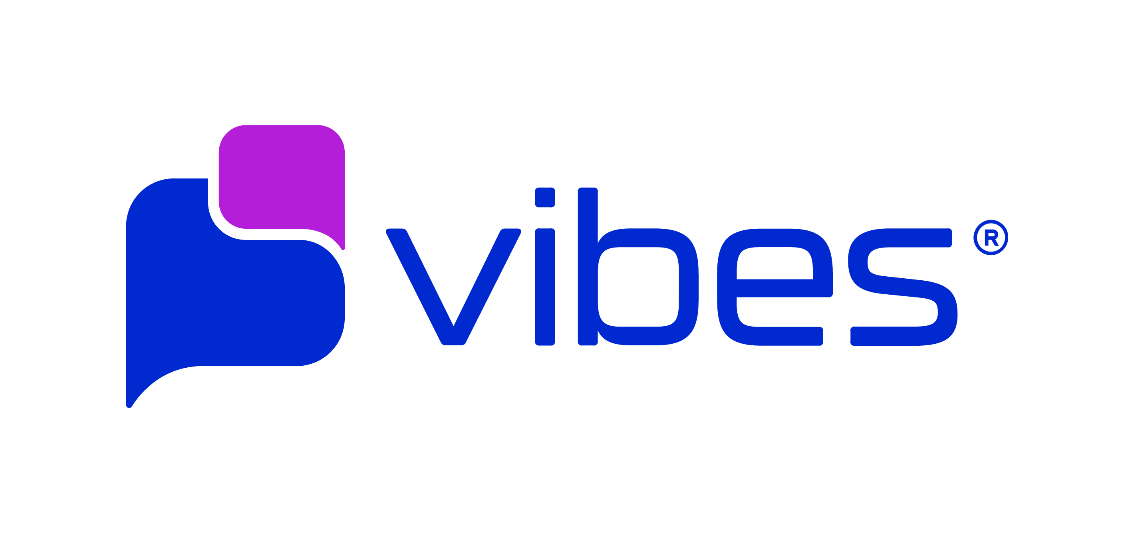
- AGENT & PROGRAM INFORMATION

Agent ID | Enter the Agent’s ID here
Program Name | Enter the program’s name here
WEB and/or WAP URL | Enter opt-in URL, if applicable

- PROGRAM DEAILS - MESSAGE FLOW & CUSTOMER EXPERIENCE

Program Summary
Please include in your program summary:
- 1-2 sentences describing the brand
- A description of the RCS content that will be sent & how the Agent will be used
- Description of where the call-to-action will be located and how new participants will opt into the RBM program.

Opt-In Interaction:
Type
CTA Language  Please include the language that will prompt consumers to enroll in this program. If web CTA, please include screenshot at bottom of the form. | CTIA Required Compliance:  Program description. Msg&data rates may apply. Message frequency. Privacy statement or link to privacy policy. Link to full mobile T&Cs page.  -OR- Sponsor name and program description. Msg&data rates may apply. Message frequency. Customer support information. Opt-out instructions. Privacy statement or link to privacy policy.
Initial Opt-In | DESCRIPTION OF WAY USER WILL PROVIDE OPT-IN CONSENT
Confirmation MT | CTIA Required Compliance: Sponsor name and/or program description. Confirmation of opt-in. Msg&data rates may apply. Message frequency. Customer support information. Opt-out instructions.  (E.g. Thanks for subscribing to PROGRAM NAME mobile alerts. To unsubscribe, reply STOP. Msg frequency is recurring, Text HELP for info. Msg&data rates may apply.)

Sample Alerts/Content Interactions
Please include an example of each content type described in the program summary.
CTIA Required Compliance: Sponsor name and/or program description in all messages. Periodic opt-out & support information.

Type
RCS Content
RCS Content
RCS Content

Help Interaction (Required for all programs):
CTIA Required Compliance: Agent or brand name. Customer support information (either a toll-free number, website, or email address)

Type | Message
MO | HELP
MT

Opt-Out Interaction (Required for all programs):
CTIA Required Compliance: Agent or brand name & confirmation that no additional messages will be sent.

Type | Message
MO | STOP, QUIT, CANCEL, END, STOPALL, UNSUBSCRIBE
MT

- AGENT PREVIEW & CERTIFICATION

The Google RCS Business Messaging team requires a preview of the agent before it launches. Reviewers can test your agent with their own devices, or you can provide a video showing opt-in, opt-out, and the agent’s core functionality/message types.

- Option 1: Agent access instructions - Provide a method for reviewers to trigger the agent, such as a website where reviewers can invite and add phone numbers. You may also request a list of phone numbers to add as test devices.
- Option 2: Video URLs - If you prefer to have your agent reviewed via video, please provide a public URL for a video.

T-Mobile RBM Certification – T-Mobile requires Agents to respond to START, HELP, & STOP with the approved copy in order to launch on their network. T-Mobile will test the Agent through the use of a deeplink QR code that will iniate testing by sending the keyword “START” to the Agent.

- Vibes will create the deeplink QR code that will be used by T-Mobile for Agent testing. But please make sure the Agent is setup to respond to START, HELP, & STOP with the approved copy.

- CTA IMAGE or URL (ONLY REQUIRED FOR WEB OPT-INS)

If this program supports a web CTA, please provide a screen shot or URL for the carriers to review the CTA.

